Tab 1
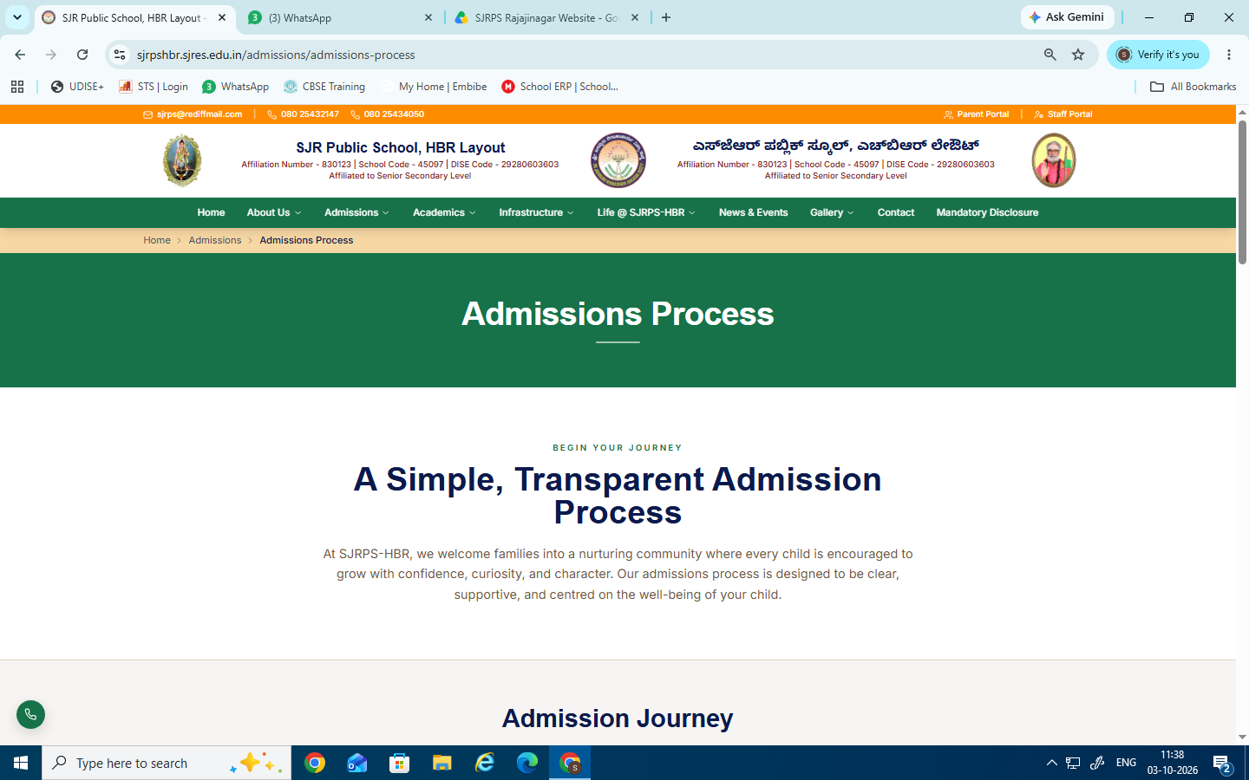
Retain this

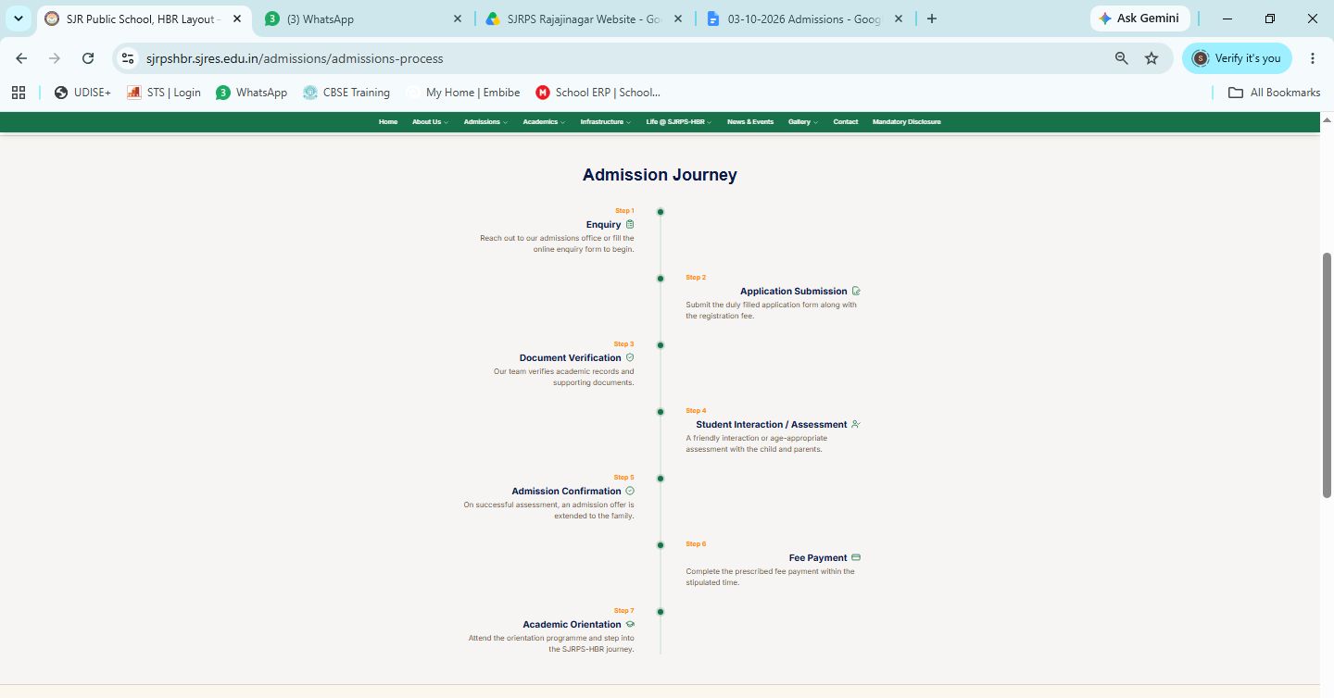

Changes to be done

Enquiry
Step 1 - Reach out to our admissions office
Step 2 - Student Interaction / Assessment
A friendly interaction or age-appropriate assessment with the child and parents.
Step 3 - Admission Confirmation
On successful assessment, an admission offer is extended to the family.
Step 4 -Document Verification
Our team verifies academic records and supporting documents.
Step 5 - Application Submission
Submit the duly filled application form along with the registration fee.
Step 6 - Fee Payment
Complete the prescribed fee payment within the stipulated time.
Step 7- Academic Orientation
Attend the orientation programme and step into the SJRPS-Rajajinagar journey.


Retain this
Change to be done
Why SJRPS-Rajajinagar

Why Choose SJRPS-Rajajnagar?
Rest all retain the same

Changes to be done

Admissions at SJRPS-Rajajinagar are not just about enrolment — they are the beginning of a lifelong partnership in your child's growth and success."


Retain this

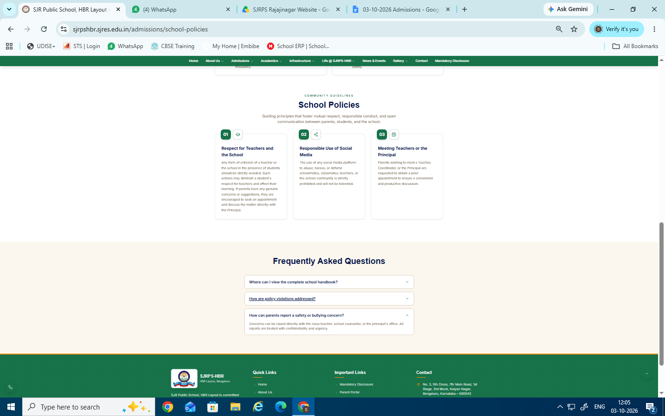
Retain this
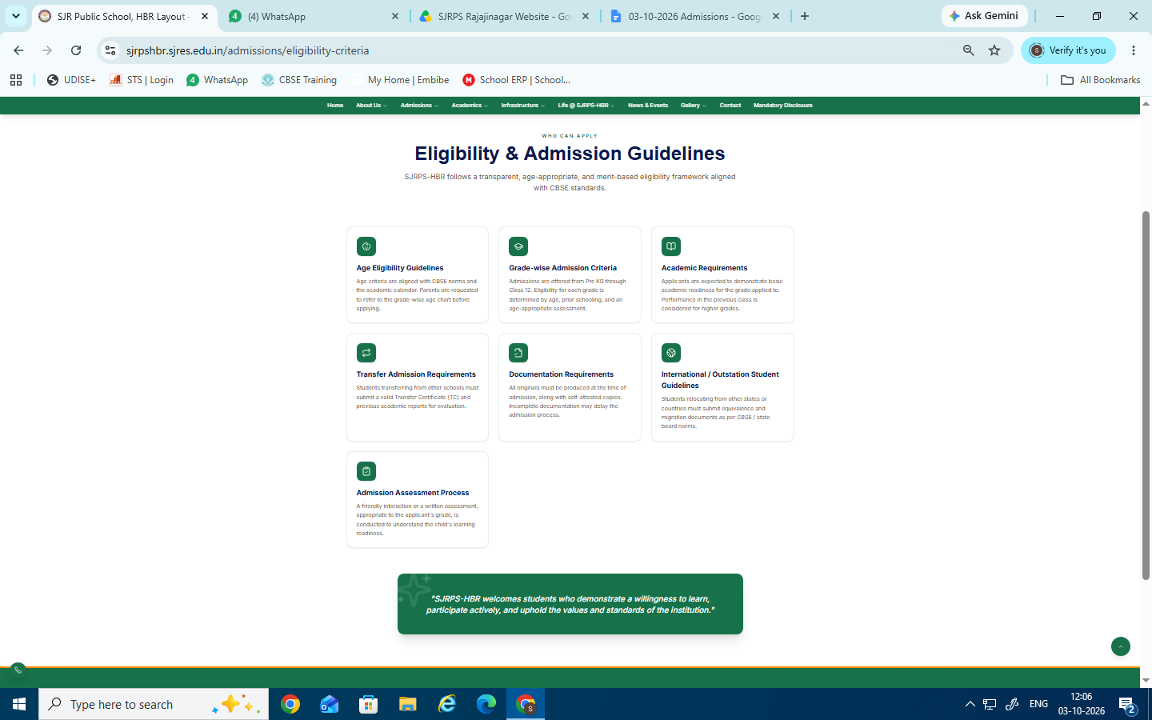
Changes to be done

Grade-wise Admission Criteria
Admissions are offered from Pre KG through Class 10. Eligibility for each grade is determined by age, prior schooling, and an age-appropriate assessment.
- Rest all retain the same
- "SJRPS-Rajajinagar welcomes students who demonstrate a willingness to learn, participate actively, and uphold the values and standards of the institution."

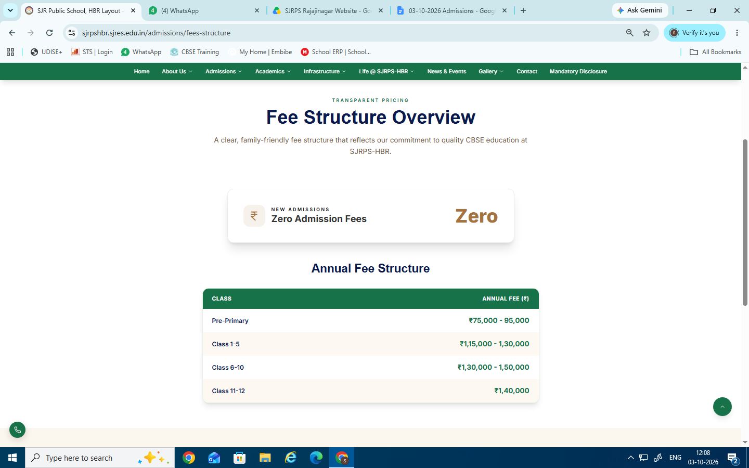
Changes to be done
- A clear, family-friendly fee structure that reflects our commitment to quality CBSE education at SJRPS-Rajajinagar.
- Remove new admission block
- Annual fee structure
SJR Public School ,Rajajinagar– New Admission Fees 2025–26
Sl. No. Class Total Fee per Annum (₹)

1 Pre-Nursery 58,000
2 LKG 63,000
3 UKG 63,000
4 I to V Std. 73,600
5 VI to VIII Std. 79,200

Re-Admission Fees 2025–26
Sl. No. Class Total Fee per Annum (₹)

1 Pre-Nursery to LKG 55,000
2 LKG to UKG 55,000
3 UKG to Grade I 59,700
4 Grade I to Grade II 59,700
5 Grade II to Grade III 59,700
6 Grade III to Grade I 59,700
7 Grade IV to Grade V 59,700
8 Grade V to Grade VI 66,900
9 Grade VI to Grade VII 66,900
10 Grade VII to Grade VIII 66,900
11 Grade VIII to Grade IX 66,900
12 Grade IX to Grade X 70,400

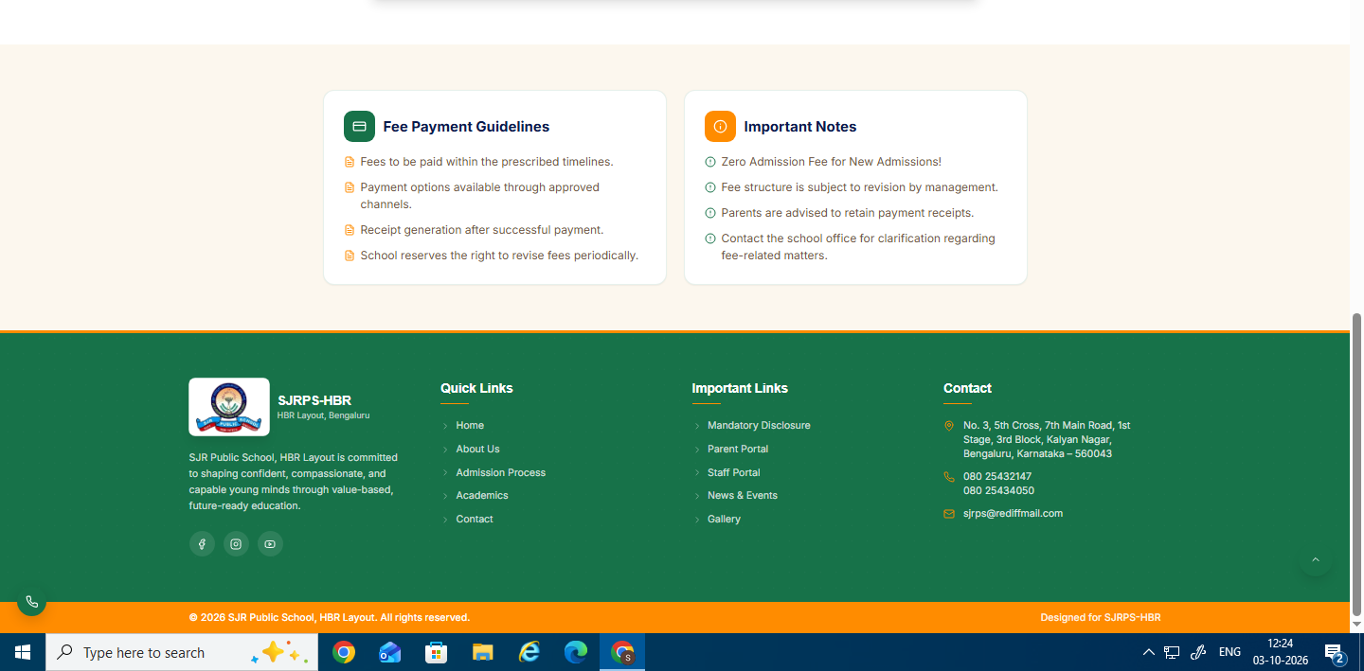
Retain this

